**Question-1**

**Implement CSS Selectors target HTML elements to apply styles by**

**taking any example.**

<html>

    <head>

        <tit<le>semantic HTML tags</title>

    </head>

    <body>

        <header>

            <h1>Navbar</h1>

            <nav>

                <ol>

                    <li>

                        <a href="http://www.amazon.in">Home</a>

                    </li>

                    <li>

                        <a href="#about">About</a>

                    </li>

                    <li>

                        <a href="#contact">Contact</a>

                    </li>

                </ol>

            </nav>

        </header>

        <article>

            <h2>This is article tag</h2>

            <p>udhdwdewdasabsgfqdscfmwdejwj</p>

        </article>

        <figure>

            <image

src="https://tiimg.tistatic.com/fp/1/007/669/yellow-cover-rectangular-single-line-a4-size-white-paper-spiral-notebook-with-224-pages-650.jpg"

alt="nootebook"

 height="100"

 width="100"/>

<h4>it is book</h4>

        </figure>

        <footer>

            <p>2025 my website.All rights reserved</p>

        </footer>

    </body>

</html>

semantic HTML tags

**Navbar**

1. [Home](http://www.amazon.in)
2. About
3. Contact

**This is article tag**

udhdwdewdasabsgfqdscfmwdejwj



**it is book**

2025 my website.All rights reserved

**Question-2**

**Implement The box model consists of margin, border, padding,**

**and content by taking a div and in that write text using heading and**

**paragraph tag.**

<!DOCTYPE html>

<html lang="en">

<head>

    <meta charset="UTF-8">

    <meta name="viewport" content="width=device-width, initial-scale=1.0">

    <link rel="stylesheet" href="style2.css">

    <title>Document</title>

</head>

<body>

    <div class="box">

        <h1>CSS Box Model</h1>

        <p>the box model consists of margin,padding,border and content.</p>

    </div>

</body>

</html>

body{

    font-family: Arial, sans-serif;

    background-color: rgb(151, 198, 214);

    text-align: center;

}

.box{

    width:300px;

    margin:20px auto;

    padding: 20px;

    border:5px solid;

    background-color: rgb(159, 47, 47);

    box-shadow: 5px 5px 10px rgba(0,0,0,0,2);

}

h1{

    font-size: 22px;

    color:#fcf9f9;

}

p{

    font-size: 16px;

    color:#0bba4e;

}

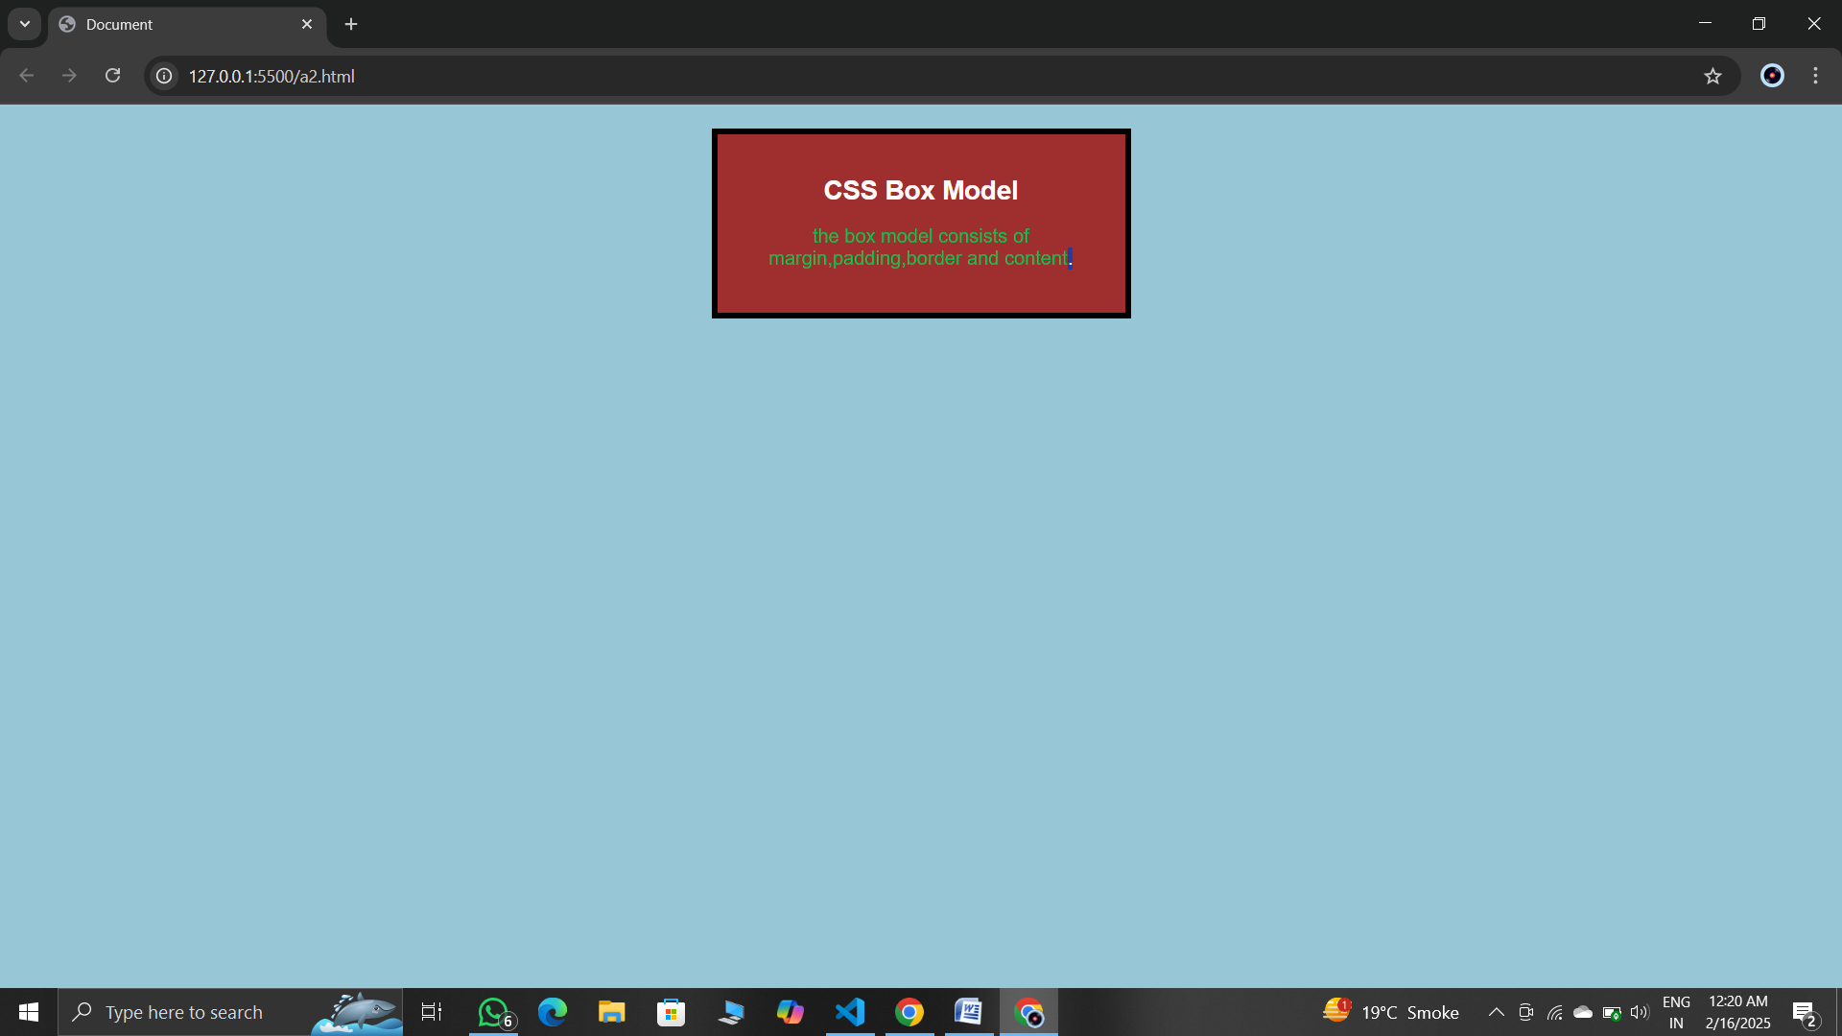

**Question-3**

**Make Registration Form Using Radio Button, Checkbox,**

**Submit, and Reset Button**

<html>

    <head>

        <title>Student Ragistrastion from</title>

    </head>

    <body>

        <from>

            Enter your first name

            <input type="text">

            <br>

            <br>

            Eneter your midal name

            <input type="text">

            <br>

            <br>

            Email<br>

            <input type="text" id="email" name="email">

            <br>

            <br>

            Gender:

            <br>

            <input type="radio" id="male" name="Gender" value="male">male

            <input type="radio" id="female" name="Gender" value="female">female<br><br>

            Interests:

            <br>

            <input type="checkbox" id="reading" name="Interests" value="reading">reading<br>

            <input type="checkbox" id="music" name="Interests" value="music">music<br>

            <input type="checkbox" id="sports" name="Interests" value="sports">sports<br><br>

            <button type="Submit">Submit</button>

            <button type="Reset">Reset</button>

        </form>

    </body>

</html>

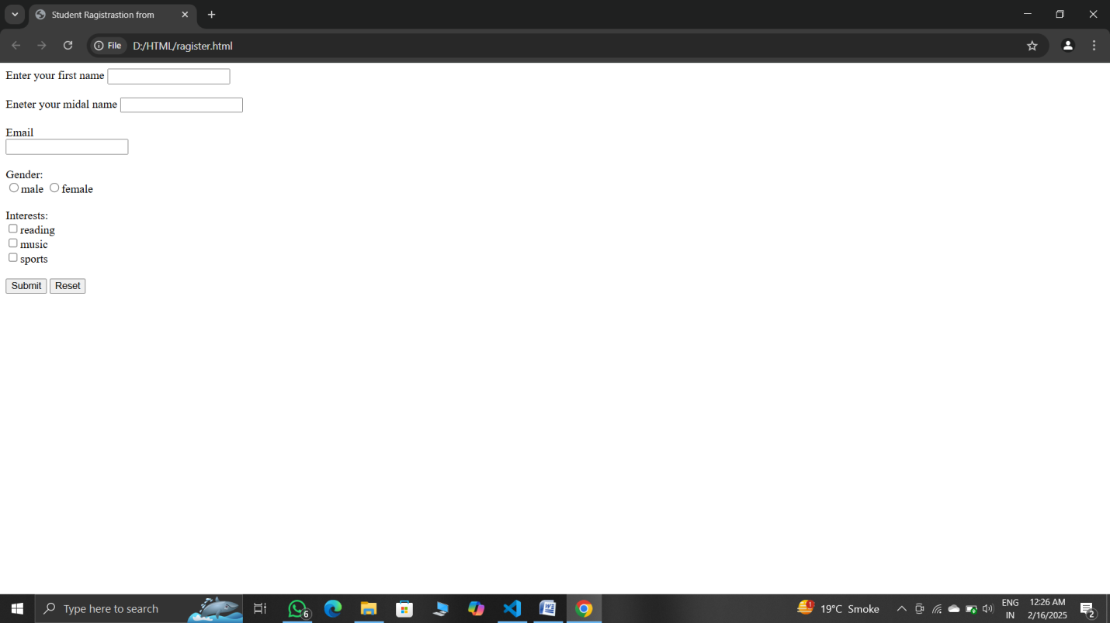

**Question-5**

**Use Media Query and Implement The background color changes**

**when the screen width is ≤ 600px. The font size changes for different**

**screen sizes. Centers text on smaller screens.**

<!DOCTYPE html>

<html lang="en">

<head>

    <meta charset="UTF-8">

    <meta name="viewport" content="width=device-width, initial-scale=1.0"/>

    <link rel="stylesheet" href="style5.css">

    <title>CSS navigation menu</title>

</head>

<body>

    <header>

        <nav>

            <ul>

                <li><a hraf="#">home</a></li>

                <li><a hraf="#">contact</a></li>

                <li><a hraf="#">Image</a></li>

                <li><a hraf="#">explore</a></li>

            </ul>

        </nav>

    </header>

</body>

</html>

*{

    padding: 0;

    margin: 0;

    box-sizing: border-box;

}

body{

    width: 100%;

}

header{

    height: 80px;

    background-color: rgb(10, 30, 69);

    display: flex;

    align-items: center;

    justify-content: flex-end;

}

ul{

    list-style-type: none;

    display: flex;

    margin-right: 30px;

}

ul li{

    margin: 0px 6px;

}

a{

    display: block;

    text-decoration: none;

    text-align: center;

    font-weight: bold;

    background-color: rgb(192, 50, 81);

    color: rgb(27, 25, 142);

    border: 1px solid;

    padding: 13px 20px;

    border-radius: 4px;

    font-family: 'Courier New', Courier, monospace;

    transition: all 0.5s ease;

}

a:hover{

background-color: rgba(189, 80, 140, 0.642);

color: blue;

}

@media screen and (max-width: 600px){

    header{

        height: auto;

        display: block;

        padding: 20px 0px;

        background-color: rgb(16, 12, 8);

        font-size: small;

    }

    ul{

        display: block;

        margin-right: 0;

    }

    ul li{

        margin: 6px;

    }

}

